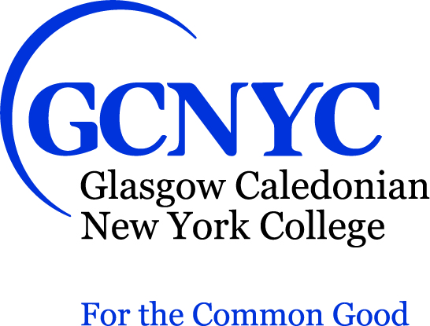

Provost
Glasgow Caledonian New York College (GCNYC)
New York, NY

GCNYC seeks to appoint a Provost to realize the potential of its ambitious, outward-looking
College. As a College for the Common Good, GCNYC is committed to providing the highest quality education and research for the benefit of society at home and across the world. Founded by Glasgow Caledonian University, GCNYC became the first international institution to receive degree-granting authority in New York, welcoming its first class in September 2017. GCNYC has grown to almost 100 students and currently offers master’s degrees in International Fashion Marketing; Impact-Focused Business and Investing; and Risk, Resilience and Integrity Management.

As the Chief Academic Officer, the Provost will report to the President of GCNYC and provide overarching leadership and operational accountability for all academic activities. The Provost is charged with promoting and maintaining a distinctive academic vision for GCNYC, catalyzing innovation, and ensuring the highest levels of quality as the College grows. The Provost is responsible for ensuring the College’s successfully receives accreditation, and thereafter maintaining compliance with accreditation quality standards and assessment data. The Provost will have oversight of 15 adjunct faculty, four staff, and an initial income target of $4 million.

GCNYC is looking for an experienced leader with excellent communication skills and the ability to engage a diverse array of stakeholders. The Provost will bring experience in administration at a U.S. higher education institution and have worked with regulatory and accrediting bodies. The Provost will demonstrate drive, commitment, creativity, and integrity in line with the values of the GCNYC. The Provost will be an excellent coach and mentor who is committed to diversity and equity along with widening participation in higher education. A doctorate, research experience, and a strong commitment to responsible leadership, sustainable business/corporate social responsibility, or a related area are required.

Inquiries, nominations, and applications should be sent in strict confidence to Isaacson, Miller via www.imsearch.com/7173

GCNYC is an Equal Opportunity Employer.

