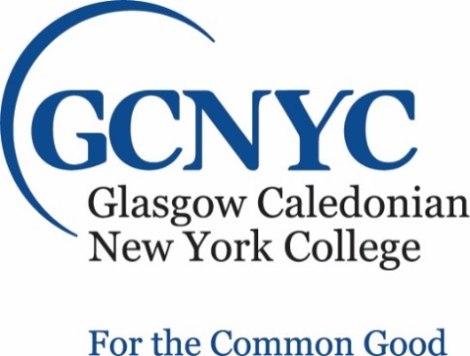
Assistant/Associate Professor
GCNYC: | Caledonian New York College (GCNYC)
Role:  Contract:  Salary : | Assistant/Associate Professor  This non-tenure track, renewable, three-year appointment will begin in 2020.  Salary and benefits are competitive.
Closing date: | 1 November 2019
Glasgow Caledonian New York College (GCNYC) leverages the 144 years of academic excellence of its founding sponsor, Glasgow Caledonian University, to bring to NYC a distinctly global perspective and degree programs focused on profitable sustainability and committed to a “For the Common Good” mission. Located in the vibrant SoHo area of New York City, and with strong ties to world-class businesses and the fashion industry as well as to the United Nations, GCNYC delivers unique programs leading to the MS degree in International Fashion Marketing; Impact-Focused Business and Investing; and Risk, Resilience and Integrity Management. Grounded in the UN Sustainable Development Goals, these programs are designed for adult students who enter as experienced professionals in their sectors and graduate prepared for roles as responsible leaders possessing the analytical skills and clear values necessary to fashion successful careers as globally minded corporate statesmen and women.

GCNYC seeks a faculty colleague at the assistant/associate level who is prepared and eager to teach in and lead continued development of our programs. The successful candidate will have the following requirements:

- a Ph.D. from a regionally accredited institution or equivalent in a relevant field; professional experience in sustainability, social entrepreneurship or corporate social responsibility is a plus.
- at least three years of full-time teaching experience and campus involvement at an institution of higher education;
- a record of research and publication in areas such as sustainability, social entrepreneurship, and corporate social responsibility as well as the potential to publish in quality academic journals in these areas; and
- strong methodological skills and excellent communication skills.

The College operates on a ten- month year organized into trimesters. Each trimester, the new colleague will teach one or two courses and supervise master’s theses. They will also serve the Curriculum Committee and Academic Board, serve as lead faculty for the core curriculum, continue to develop professionally in their academic field and contribute to the scholarship of their field, advise students and contribute to the intellectual life of the College. This non-tenure track, renewable, three-year appointment will begin in 2020. The salary and benefits are competitive.

GCNYC is an Equal Opportunity Employer. The College is committed to providing an inclusive and respectful environment for all members of its community. GCNYC’s full Equal Employment and Opportunity Policy can be found in the GCNYC Faculty Handbook, and our Dignity at Work and Study Policy can be found on our website at: gcnyc.com
GCNYC is aligned with GCU’s mission is to be a University for the Common Good. Its core values of integrity, creativity, responsibility, and confidence are integral to everything it does and how it delivers its mission.
Application Procedure: To apply for this position, please submit a copy of your Curriculum Vitae, letter of interest addressing the qualifications, one page statement of teaching philosophy, and at least 2 current professional references (with full contact information) to recruitment@gcu.ac.uk. Applications received by November 1, 2019, are assured of full consideration. However, applications will be accepted until the position is filled. Questions regarding this opportunity should be directed to (646) 768-5300.

